Assignment 2:

Implementation of RLS (row level security )in SQL server with example

1. Created a table (employee) and inserted some data in it.

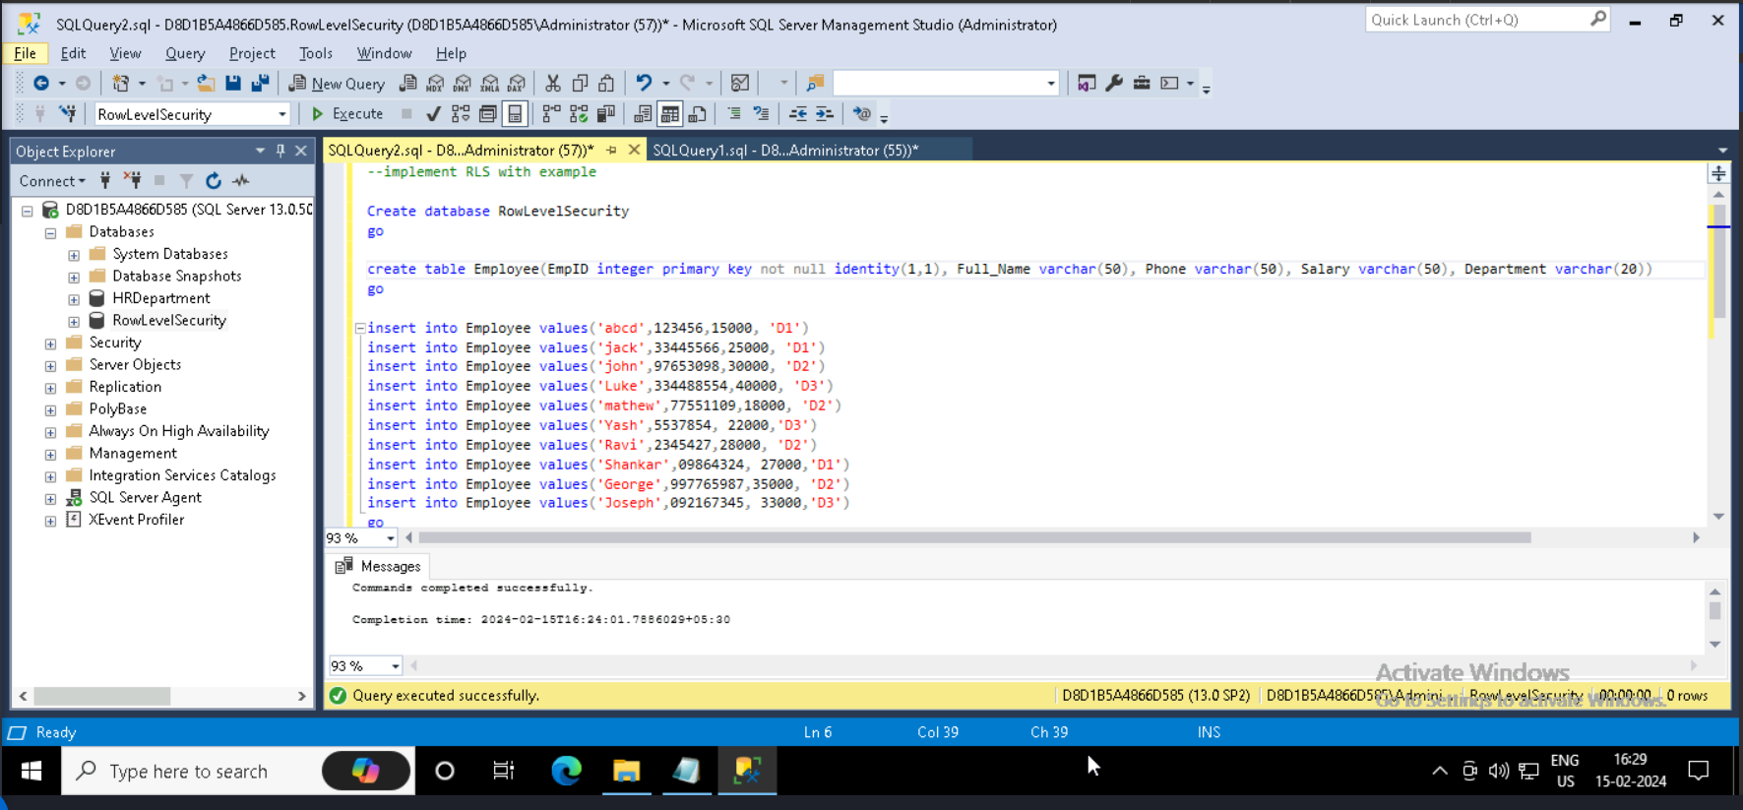

1. Created login for corresponding department Leads and also created login for Project manager.

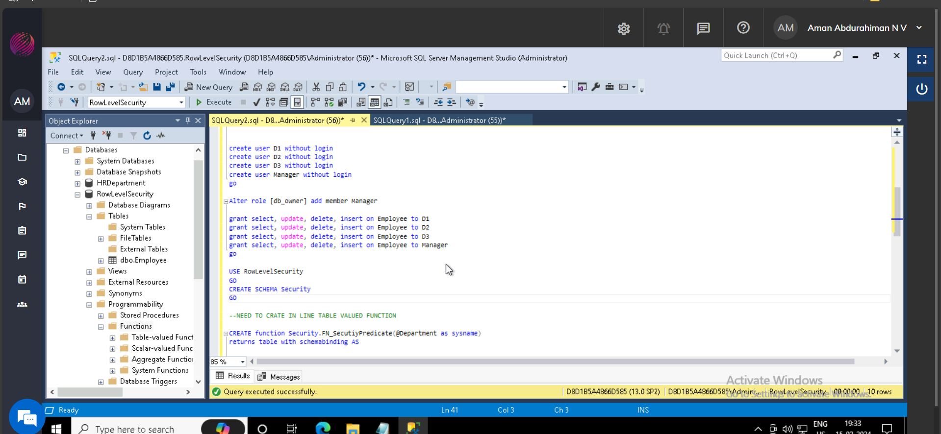

1. Created a schema, table valued function and post that created a Security policy. Such that the row level data will filter out accordingly, As shown below.

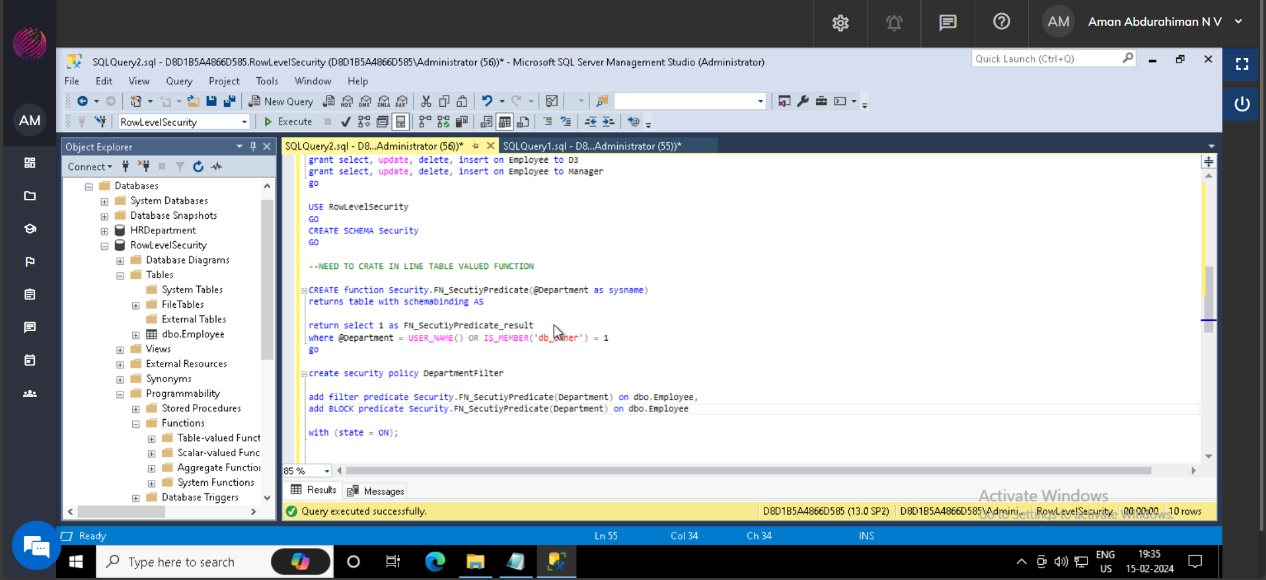

1. Output:

accessing the table data which executed as each department Lead, which only shows corresponding employees.

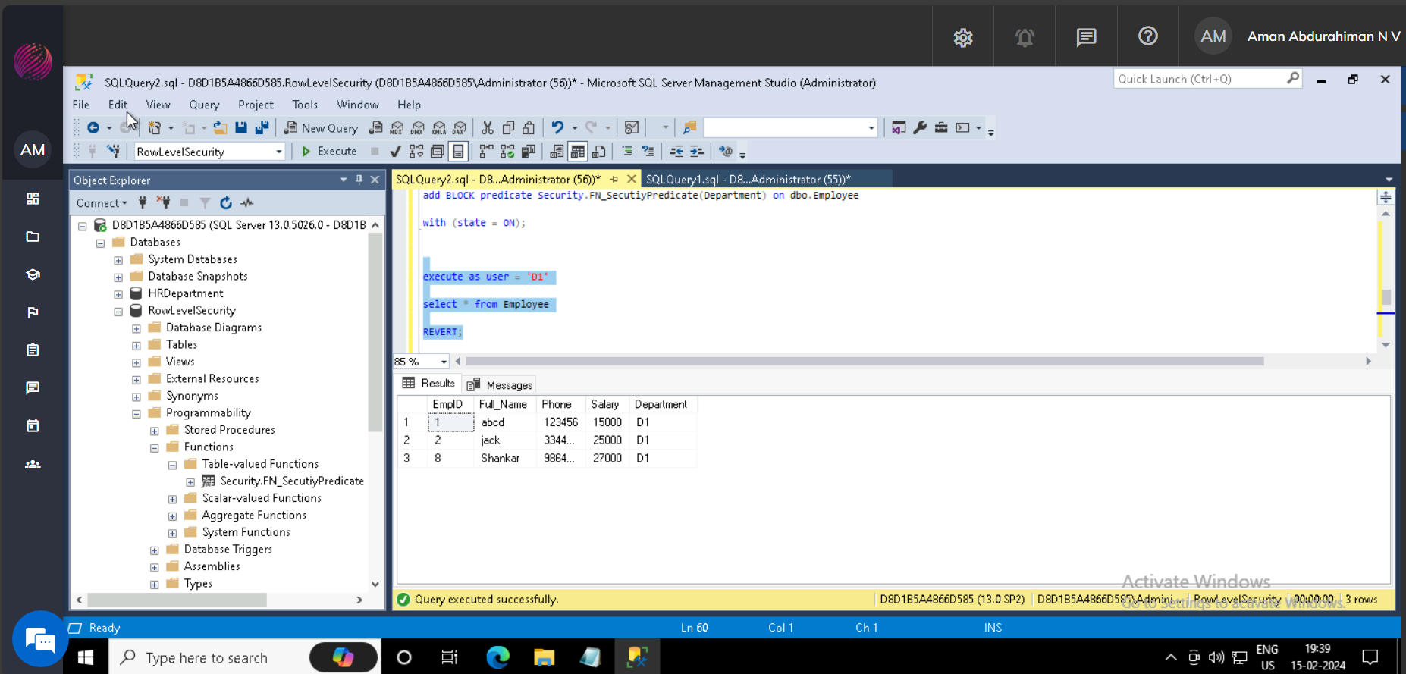

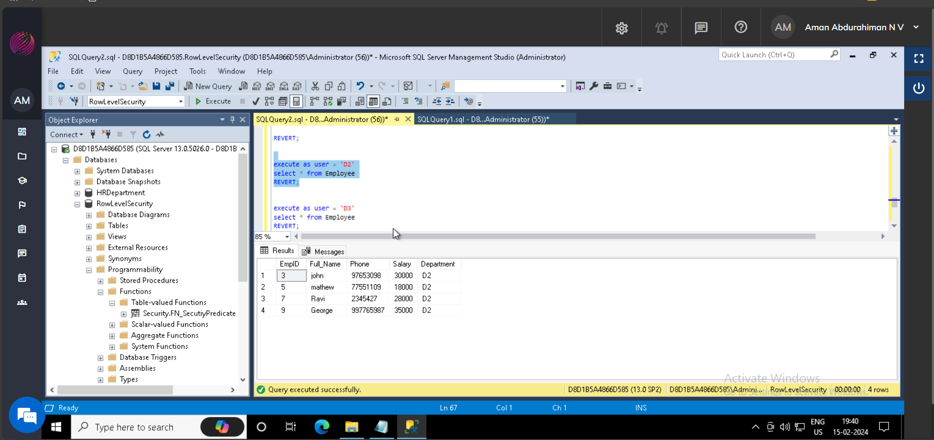

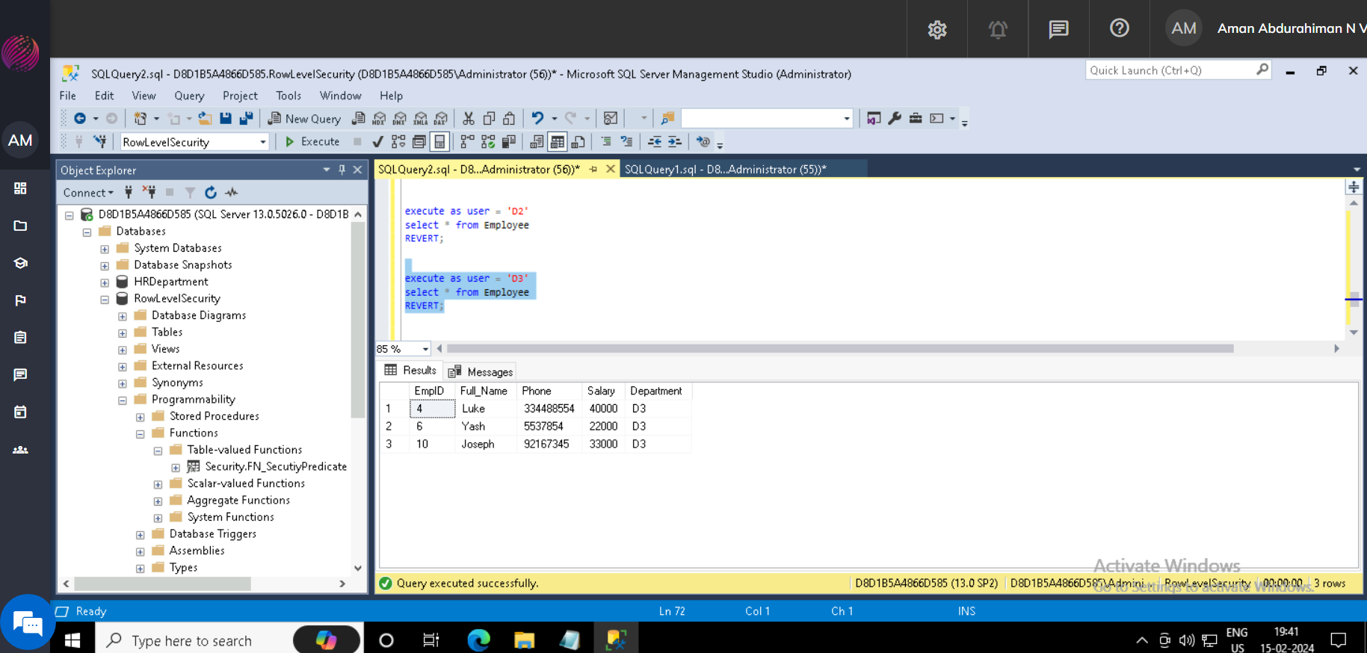

Below is the scenario which data is accessing by the Project Manager, which will give details of all employees.

